11.95: Assume that the center of gravity of the loaded girder is at 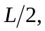 and that the cable is attached a distance x to the right of the pivot. The sine of the angle between the lever arm and the cable is then 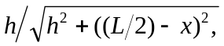 and the tension is obtained from balancing torques about the pivot;
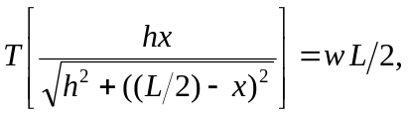
where is the total load (the exact value of and the position of the center of gravity do not matter for the purposes of this problem). The minimum tension will occur when the term in square brackets is a maximum; differentiating and setting the derviative equal to zero gives a maximum, and hence a minimum tension, at 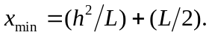 However, if 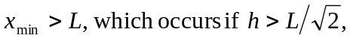 the cable must be attached at L, the furthest point to the right.

